Fish Passage Program A project to bring migrating fish back to the river
http://blackstoneriver.org/blackstone/wp-content/uploads/2010/02/Fish_Passage_Brochure.pdf

Fish Passage Background
Powering the Rebirth of Our Mighty Blackstone Bringing Migrating Fish Back to Our Valley
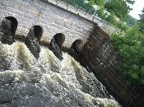
There was once a time in the Valley when migrating fish drew crowds of people, flocks of birds, and many other wildlife species to the banks of the Blackstone. Over 200 years ago, this ancient process stopped, when the river’s flow was abruptly interrupted by dams of the Industrial Revolution.
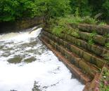
Today we no longer rely upon these dams to power our economy. Many remain in place however, continuing to not only block fish from their native spawning grounds, but keeping wildlife and people from enjoying the resources and excitement of annual fish runs.
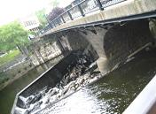
Our Goal is to construct fish
ladders or remove dams so that the river can once again draw people and wildlife to its banks.
It’s not a possibility, it’s a reality…
…and you can help!

History of the Fish Passage
Powering the Rebirth of Our Mighty Blackstone
Bringing Migrating Fish Back to Our Valley
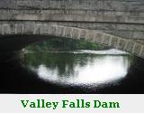
A Historic Valley
Most people in the Blackstone River Valley are familiar with its industrial history, however they may not be as familiar with the impacts of this industry.
At one time, the Blackstone was a wide, wild river—habitat for many species of fish and other wildlife. The Blackstone was breeding territory for shad, herring, and even Atlantic salmon. These are called anadromous species which hatch in freshwater, migrate to the ocean, and return to their native river to breed (spawn).
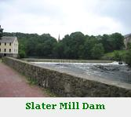
Deterioration of the River
The construction of Slater Mill Dam in 1793 initiated the decline of anadromous fish in our area. Dams and mills along the river blocked migration and contributed to heavy pollution of critical habitat.
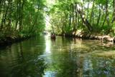
Bringing the River Back
In the past 30 years, the Blackstone has seen dramatic improvements. As a result of community efforts and environmental legislation (especially the Clean Water Act of 1972), freshwater fish and wildlife are abundant, and people are once more enjoying nature along the Blackstone.
What are the next steps for bringing the fish back?

Fish Passage- Next Steps
Powering the Rebirth of Our Mighty Blackstone
Bringing Migrating Fish Back to Our Valley
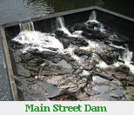
What Now?
With improved water quality and the success of the Lonsdale Drive-in Wetland Restoration Project, breeding habitat is available, and the return of anadromous species is possible. The Blackstone is ready and beckoning. It is time that wild, native fish return to complete the Rebirth of Our River. With the help and support of our government, community organizations, and citizens, we can make our fish ladder project a reality.
Progress & Vision
In the past few months, members of the organizations involved have met with town, state, and federal officials, receiving support and commitment. We are actively seeking partnership with dam owners along the river to find options that are beneficial for all.

Phase 1: Complete the master plan focused on the first four dams (see map), and begin passage installation. | 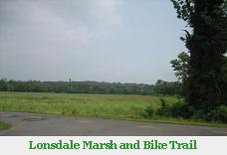 | Phase 2: Complete the goal of bringing shad, herring, and even salmon back to their native spawning grounds in Massachusetts by installing passage systems on the 4 dams between Valley Falls and the Massachusetts border.
What are the benefits of this project?

Fish Ladders - Benefits
Powering the Rebirth of Our Mighty Blackstone
Bringing Migrating Fish Back to Our Valley
Project Benefits
Restoration of anadromous fish to the Blackstone River would provide substantial ecological benefits for the Blackstone River watershed and the Narragansett Bay Ecosystem, as well as economic benefits for the communities of the Blackstone Valley and beyond. Specifically, the re-established fish runs would provide:
- Forage for valuable commercial and recreational fish species such as bluefish, striped bass, bass and pickerel
- Forage for predatory birds such as waterfowl, wading birds, and osprey
- Enhanced fishing opportunities for urban anglers
- Educational opportunities and aesthetic benefits to visitors at Slater Mill and other areas
- Enhanced opportunities for tourism and recreation in the Blackstone River Valley Heritage Corridor
What Can YOU Do?
- Contact your municipal and legislative officials to show support for the project.
- Give support to participating dam owners.
- Attend upcoming programs and information sessions
- Join the effort by becoming a member of BRWC/FOB

